We decided to go with a map theme.  There will be islands on the map with the headings for each section.  When the mouse hovers over an island, the text will show up.  We are thinking of making the map look like those animated maps you see on games, but it won't be exactly like that.  We are also thinking we could have a boat floating on the water in the map.  It would be cool if we could figure out how we can make the boat follow the mouse, but I don't know if we'll be able to.

Large Wireframe:

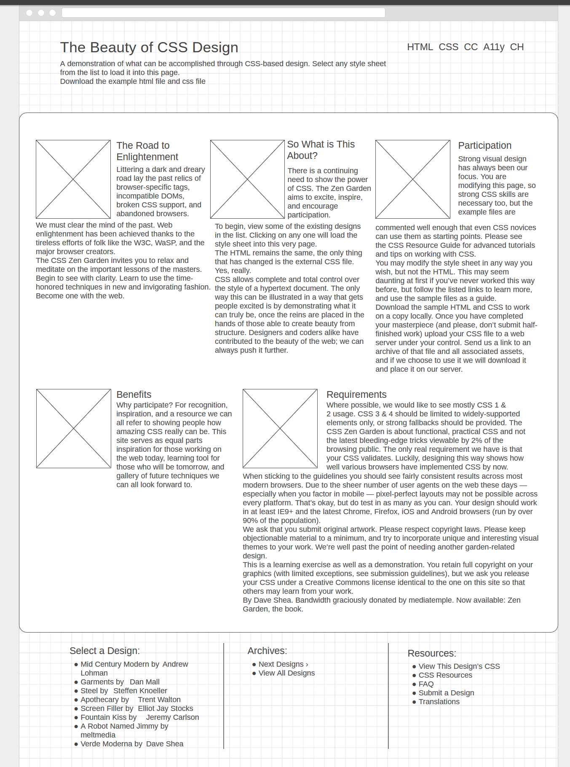

Small Wireframe:

